remote server monitoring & reporting

server monitoring

Server reporting

Monitor server performance: CPU, Memory, Disk read and write, process and bandwidth usage. Check users currently connected.

website monitoring

Easily check that all your websites have been running properly over the period of your choice. Get real-time reports on availability and response-time/code.

alerts management

Create customized or standard reports for items like concurrent sessions, network usage, server performance, user presence, that you can export, print or email.

Automatically get server and website alerts by email when standard thresholds are passed, or situation is back to normal. Set customized alerts for specific key metrics.

reports customization

All data, reports and features are accessible in a click from the single easy-to-use dashboard. The home page enables checking the entire monitored infrastructure at a glance.

Quickly add a company logo, change colors and chart types. Filter server data the way you want. Hide the elements that aren't needed in your reports.

central dashboard

www.tsplus.net/server-monitoring

CONTACT US

VISIT OUR WEBSITE

sales@tsplus.net

Real-time server and website monitoring software for remote work infrastructures. Get historical and real-time data about your servers, websites, applications and users.

Monitor servers, websites, applications, and users from one place

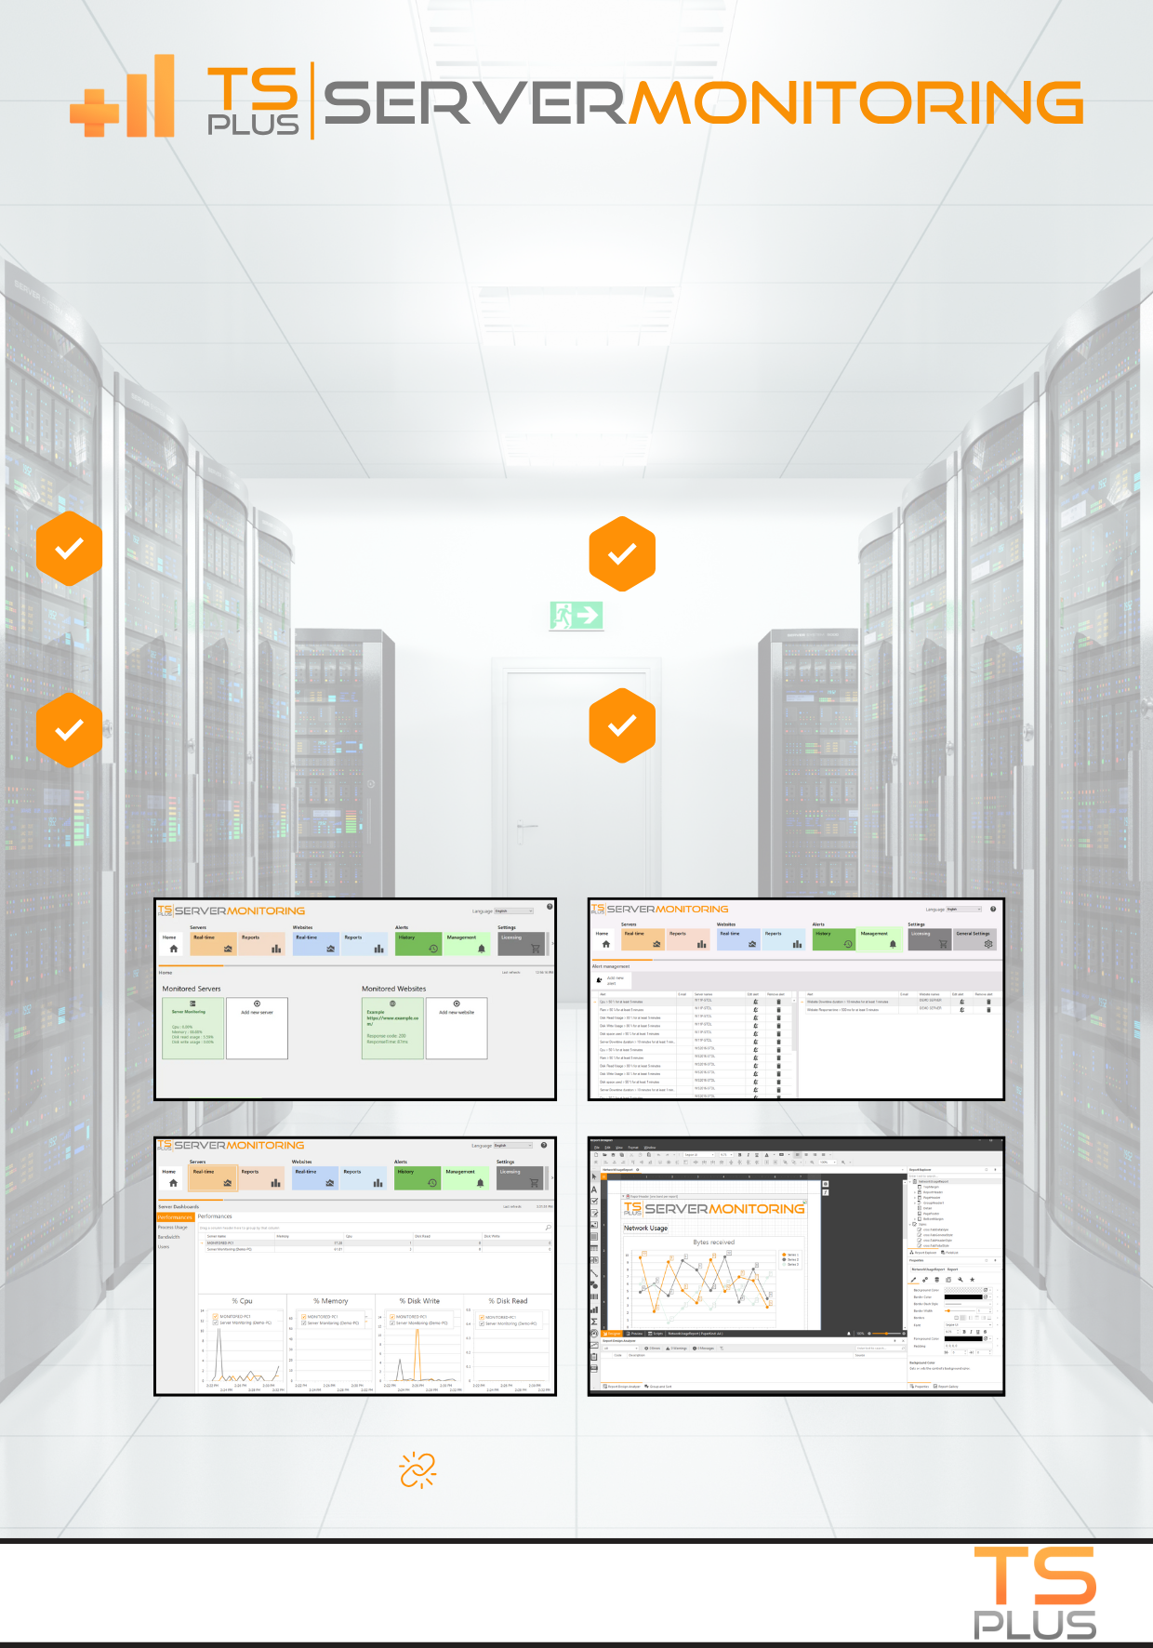

CONTACT US

sales@tsplus.net

VISIT OUR WEBSITE

www.tsplus.net/server-monitoring

Cost-saving: Server Monitoring helps you optimize your server resources, reducing unnecessary costs. Plus, it offers perpetual licenses!

Easy setup: Quick to deploy. Just install a small agent on each server to monitor and you're good to go! Check all your infrastructure at once.

Intuitive: The Admin Console is user-friendly, with a simple way to centrally monitor complex networks, multiple websites, and remote user activity!

TSplus Server Monitoring tracks server and website health from one interface. It gives you facts and data about your servers, applications and users to understand usage and performance. With real-time alerts and customizable reports, you can predict and troubleshoot issues faster!

**centrally monitor & optimize remote infrastructures**

[**LEARN MORE**](https://tsplus.net/server-monitoring/)

Customizable reports: Create and schedule regular reports with real time and historical data; Set automatic emails to your team.