**avec une confiance faible**





**The complete Remote Access software suite**

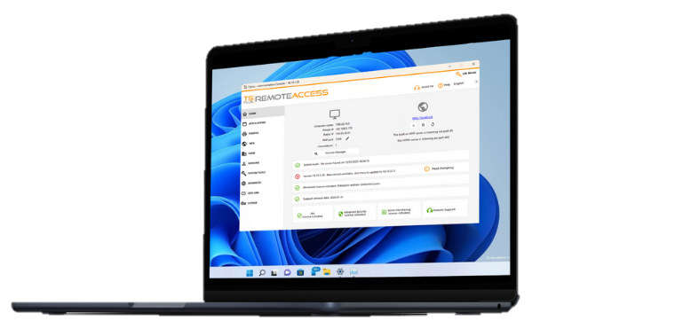

4 Remote Desktop and Application Delivery Solutions for IT Professionals. Our family of software covers a wide range of remote access needs with a core value: simplicity.

**TRUSTED BY OVER 500,000 COMPANIES**

2025

**EDITION**



AFFORDABLE TECHNOLOGIES

**BENEFITS FOR YOUR BUSINESS**

FAST TO SETUP AND DEPLOY



USER-FRIENDLY INTERFACE

PERPETUAL LICENSES



[sales@tsplus.net](mailto:sales@tsplus.net)

France, USA, Czech Republic, India, China, Africa

[www.tsplus.net](https://tsplus.net/)

SECURE CONNECTIONS

SCALABLE SOLUTIONS



**Remote**

**Access**

REMOTE ACCESS

Remote Desktop and Application Delivery

**Secure, Scalable and Cost-Effective**

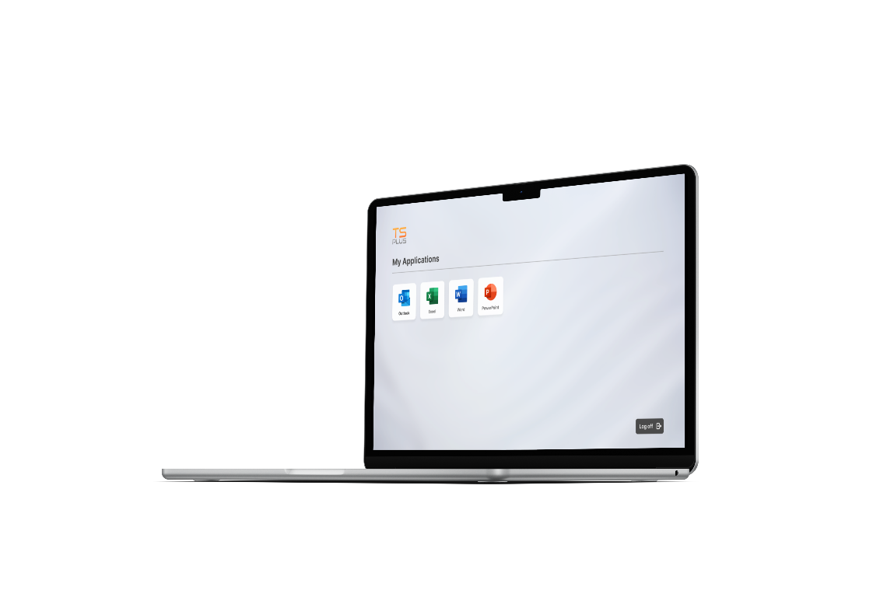



**Secure Remote**

**Access**

**Web App Portal**

**Server Farm Management**



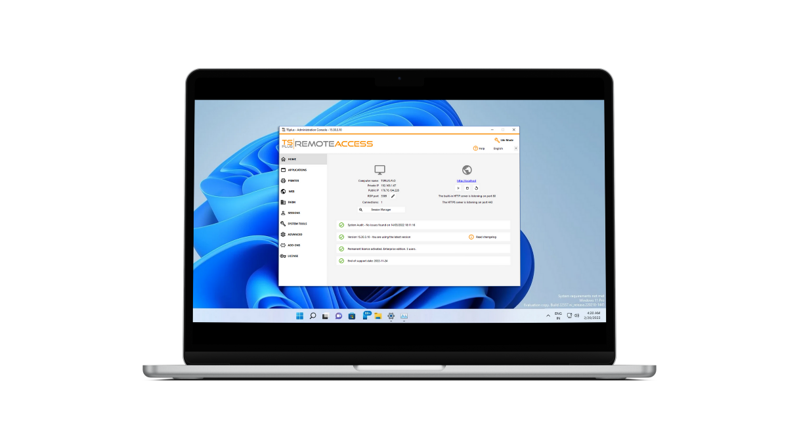

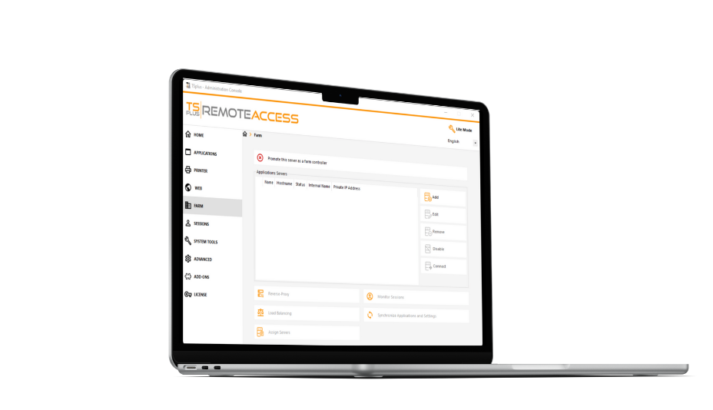

**Web-Enable Apps**

**Custom Solution**

**Enterprise Features**



Publish Windows apps on a cloud or corporate server and give direct access to remote users on any device via RDP or HTML5 clients.

Various connection modes and settings available to build a secure remote infrastructure: 2FA, SSL encryption, remote printing...

fROM $180 FOR 3 userS

(DESKTOP EDITION)

1 year of Updates and Support INCLUDED!

[**Buy Now**](https://tsplus.net/pricing/)

[www.tsplus.net/remote-access/](http://www.tsplus.net/remote-access/)

Advanced Settings adapted to the needs of large organizations: server farm, load-balancing, reverse proxy, gateway portal...



**Advanced**

**Security**

ADVANCED SECURITY

## Remote Desktop Security

### Sessions and Servers Protection

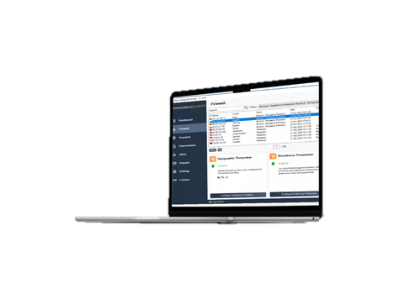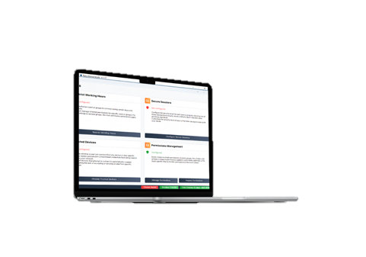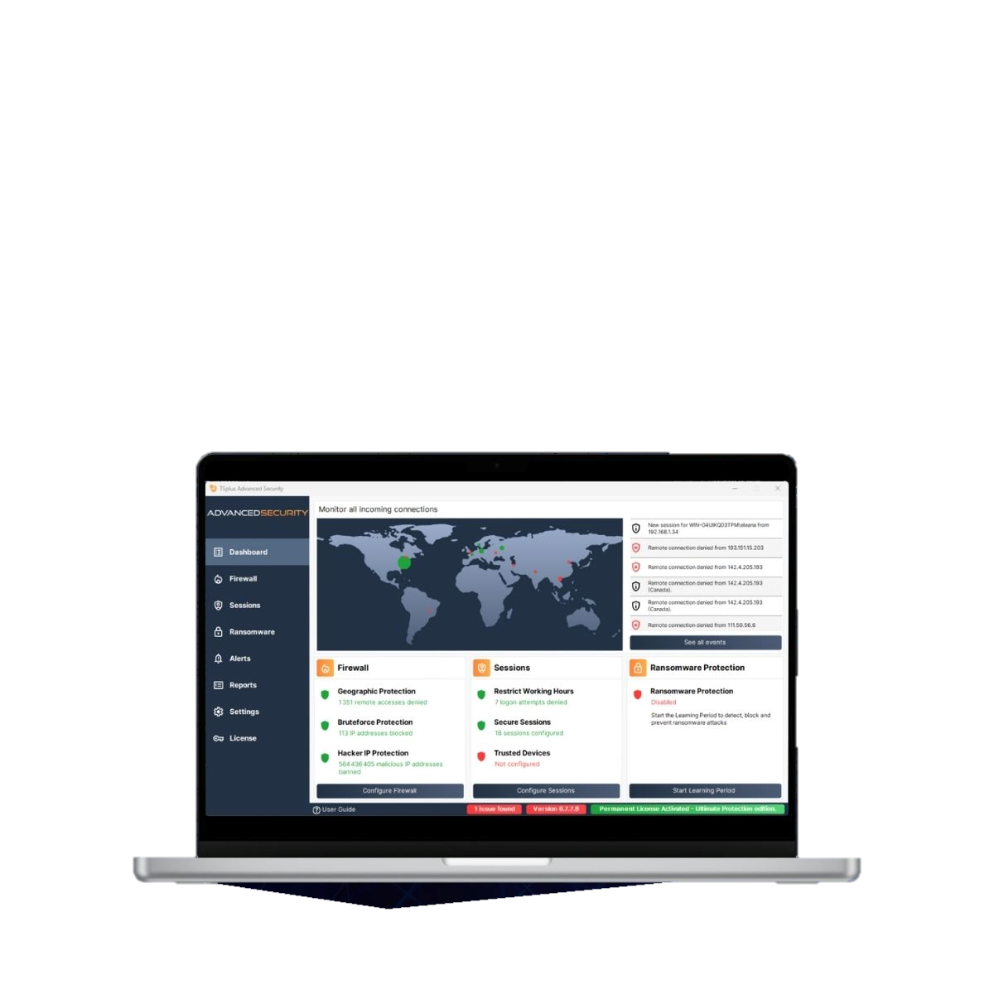

**Access Restriction**

**Attacks Defender**

**User Rights Policies**

**Efficient from Day 1**

**Up to 7 Features**

**Easy Management**



from $180/SERVER

(4 features - essentials edition)

1 year of Updates and Support INCLUDED!

[**Buy Now**](https://tsplus.net/pricing/advanced-security/)

[www.tsplus.net/advanced-security/](http://www.tsplus.net/advanced-security/)



Automatically blocks +564 million known hacker IP addresses. Monitors all risks and actions in the Event logs.



Limits connections by country, time of the day and devices. Blocks brute- force and ransomware attacks.



Easy to setup on a Windows server or desktop. Live connections map & central IP addresses management.



**Remote Support**

Remote Support

Windows, macOS & Android

Session Sharing

**Cost-effective and Secure**

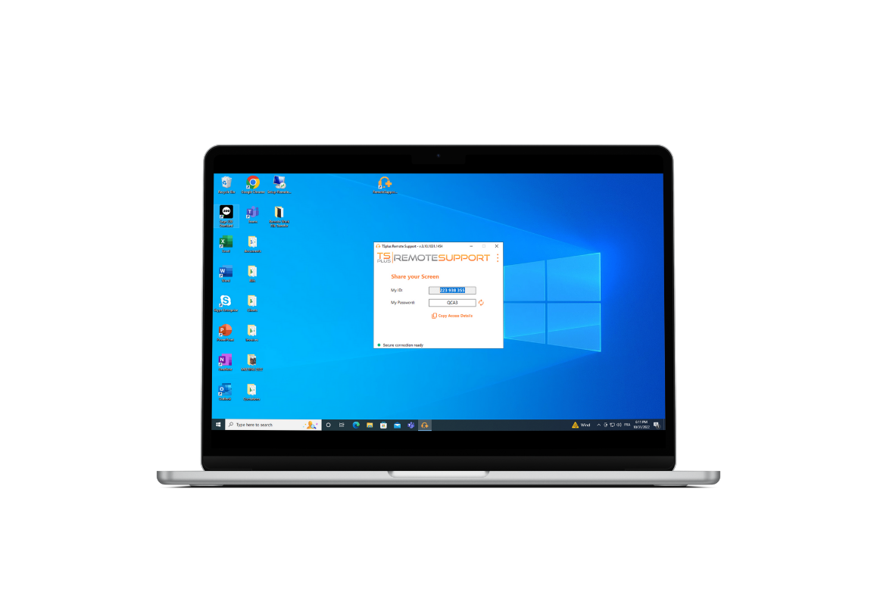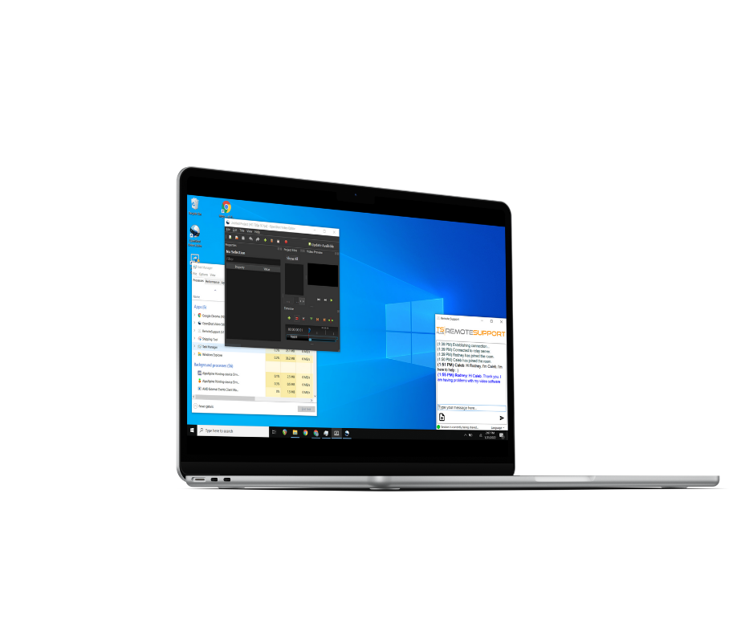



**Unattended Access**

**Screen Sharing**

**Remote PC Control**

**Collaboration Tools**

**Quick Connection**

**Zero Installation**



Small program to download and run on both sides. No setup needed.

Lite Connection Client. Session sharing in a click with ID and Password.

from $6/MONTH

(5 concurrent connections)

1 year of updates and support included!

Chat box, file transfer, multi- agents connections, send command lines, screen recording, and more.

[**Buy Now**](https://tsplus.net/pricing/remote-support/)

[www.tsplus.net/remote-support/](http://www.tsplus.net/remote-support/)



**Server Monitoring**

# Server monitoring

## Server and Website Monitoring & Reporting

### Comprehensive, Easy-to-Use, and Accurate

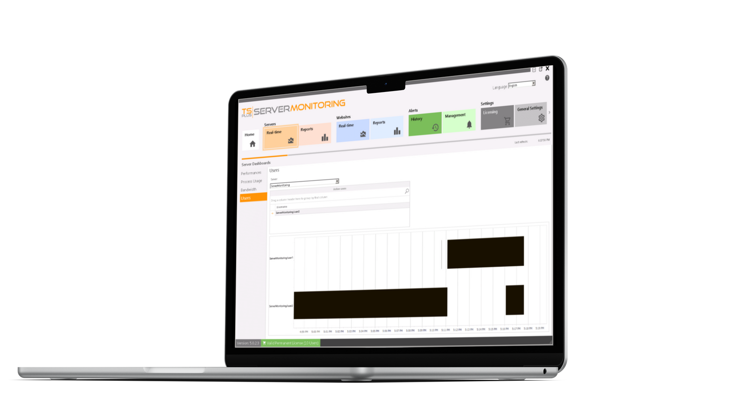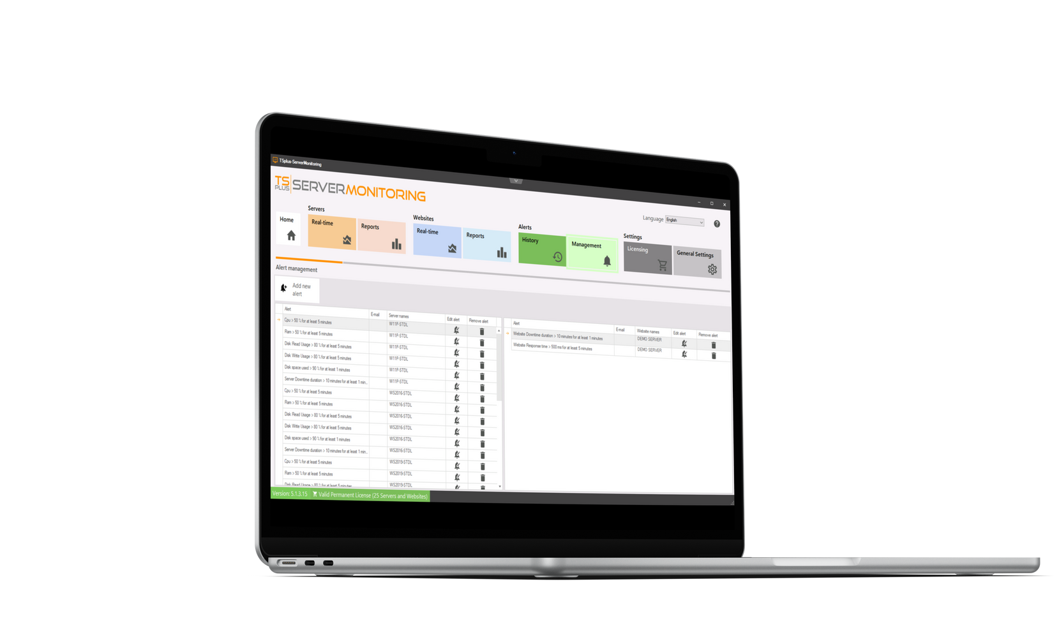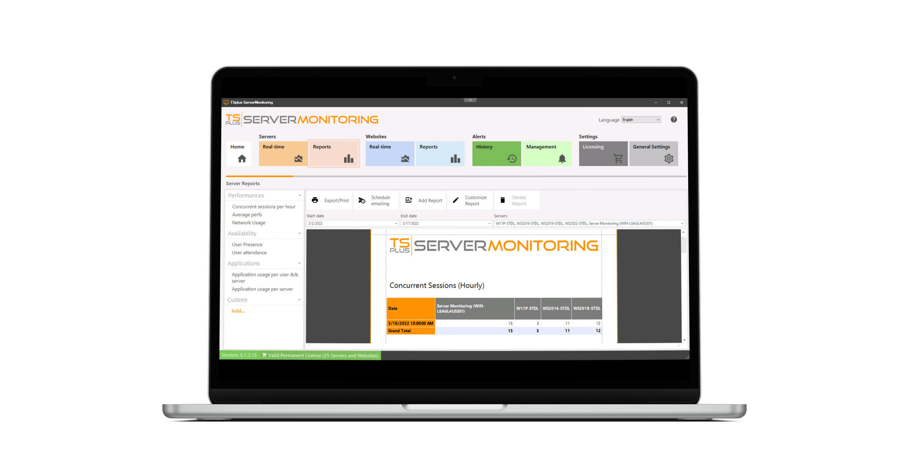

**Real-Time Monitoring**

**Custom Reporting**

**Automatic Alert System**

#### Remote Access Monitoring

Monitors all servers, websites, apps, and users of a remote work infrastructure from one place.



from $110 FOR 1 SERVER

(and 1 website - essentials edition)

1 year of updates and support included!

#### Network Administration

Smart and easy-to-read reports with historical and real-time data about performance and usage.



[**Buy Now**](https://tsplus.net/pricing/server-monitoring/)

[www.tsplus.net/server-monitoring/](http://www.tsplus.net/server-monitoring/)

#### User-Friendly Tool

Add or remove servers in minutes, with customization options for reports and alerts (email & pop-up).

Detailed pricing

APPLICATION DELIVERY

ADMIN TOOL

REMTOE PRINTING

WEB PORTAL &

HTML5 CLIENT

CROSS-PLATFORM CONNECTIVITY

WEB MASTER TOOLKIT

SECURE CONNECTIONS WITH HTTPS & SSH SERVER

FARM MANAGER AND GATEWAY

SCALABLE DEPLOYMENT

LOAD-BALANCING & FAILOVER SUPPORT

$1570

$970

$1360

PRICE FOR **25 USERS**

(PERPETUAL LICENSES)

BUNDLES

$300/SERVER

**$1690**

**$2120**

**BUNDLE PRICES**

UPDATES & SUPPORT (1 YEAR)

HOMELAND PROTECTION

BRUTE FORCE DEFENDER

GLOBAL IP MANAGEMENT

WORKING HOURS

RANSOMWARE PROTECTION

PERMISSIONS

SECURE DEKSTOPS

ENDPOINT PROTECTION

HACKER IP PROTECTION

$300

$180

PRICE **PER SERVER**

(PERPETUAL LICENSES)

(10 SERVERS)

(5 SERVERS)

(1 SERVER)

UP TO 1 SERVER

PERPETUAL LICENSE

UPDATES & SUPPORT (1 YEAR)

REAL-TIME REPORTING

REAL-TIME ALERTS

USER-FRIENDLY INTERFACE

30-SEC SET-UP

ALLOW COST-SAVING

$420

$780

$110

TOTAL PRICE

(PERPETUAL LICENSES)

CONCURRENT CONNECTIONS

UNLIMITED

UNLIMITED

UNLIMITED

LICENSED USERS

UNATTENDED MANAGED DEVICES

UNLIMITED

UNLIMITED

UNLIMITED

ACCESS & CONTROL COMPUTERS REMOTELY

DEVICES TO CONNECT TO

UNLIMITED

UNLIMITED

UNLIMITED

SECURED UNATTENDED ACCESS

CONNECT TO/FROM macOS DEVICES

CHAT BOX

REMOTE COMMAND PROMPT

FILE TRANSFER

MULTI-MONITOR SUPPORT

REMOTE COMPUTER INFORMATION

CLIPBOARD SYNCHRONIZATION

WAKE-UP-LAN

FAST VIDEO STREAMING

DYNAMIC SCREEN RESOLUTION

EASY SCREENSHOTS

SESSION RECORDING

BLOCK USERS INPUT







VISIT WEBSITE

CONNECT FROM ANDROID DEVICE

MULTI-AGENT CONNECTION

MULTI-SESSIONS REPORTS

$50/MONTH

$30/MONTH

$6/MONTH

SUBSCRIPTION FEE

**(BILLED YEARLY)**

AI TRANSLATIONS

ONLINE SUPPORT

AUTOMATIC UPDATES

REPORTING

CUSTOM BRANDING

COMPATIBLE WITH UAC